|  |  |
| --- | --- |
|  |  |

BIB Upgrade for COB Users

for

China CITIC Bank International Ltd

Functional Requirement Specification

|  |  |
| --- | --- |
| Version | 1.1 |
| Date | 15 June 2021 |

Revision History

|  |  |  |  |
| --- | --- | --- | --- |
| Date | Version | Revised By | Remark |
| 25/05/2021 | 1.0 | Oracle Consulting | Initial version |
| 15/06/2021 | 1.1 | Oracle Consulting | To incorporate the comment raised on 10/06/2021 |
|  |  |  |  |
|  |  |  |  |
|  |  |  |  |
|  |  |  |  |
|  |  |  |  |

Table of Contents

1 Introduction 4

1.1 Purpose of the Document 4

2 Functional Requirement 5

2.1 Overview 5

2.1.1 Summary 5

2.1.2 Assumption and Limitations 11

2.2 Functional Requirement Details 13

2.2.1 BO – BIB User Management 13

2.2.2 BIB – First Time Registration of PPTA User (Account Activation) 18

2.2.3 BIB – First Time Registration of General User (Account Activation) 23

2.2.4 BIB – User Management Service 25

2.2.5 BIB – Approval Request (Primary User & General User) 31

2.2.6 BIB – Support Trade X’press 37

2.2.7 BIB – Online Reset Password (PPTA User) 39

2.2.8 BIB - Support Remittance e-Advice 44

2.2.9 BIB – Relaxation of Soft Token Restrictions 47

2.2.10 BO – Enquiry on BIB Trade X’press Information 48

2.2.11 BO – Client Group with Higher Transaction Limits 49

2.2.12 IbBatchJob – BIB Users Name Scanning 50

2.2.13 IbBatchJob – BO Enquiry on BIB Trade X’press Information 51

2.2.14 BO - MIS Reports 52

2.2.15 BO - System Parameter Setting 53

3 Technical Design 54

3.1 System Architecture Diagram 54

3.2 Implementation Overview 54

3.3 Sequence Diagram 56

3.4 Database Schema 56

3.5 System Code for Function Menu 57

3.6 Program Modules – Business Internet Banking (BIB) 58

3.6.1 Configuration 58

4 Appendix 59

4.1 Validation/Error Message 59

4.2 Audit Log Template 60

4.2.1 Add/Delete/Suspend General User/PPTA User 60

# Introduction

## Purpose of the Document

This document describes the scopes and detail functional requirement of Multiple User Management in the China CITIC Bank International (CNCBI) Business Internet Banking (BIB) and Back Office (BO) application. Contents presented in this document are based on various discussions between Oracle Consulting project team of Oracle Systems HK and CNCBI users.

Upon acceptance and signoff process by CNCBI and Oracle Systems HK Ltd, this document will form the basis of design, development, and testing of this module.

# Functional Requirement

## Overview

This chapter provides the summary and assumption and limitations of this enhancement project.

### Summary

This project aims to provide a more comprehensive internet banking service for PBG customer and cater internet banking needs for PBG customers currently using COB. It is suggested to migrate PBG COB customers from COB to BIB and some services currently provided to COB shall be added to Business Internet Banking (BIB) and Back Office (BO) application in order to achieve the internet banking needs.

To fulfill the requirements, the account structure of BIB and multiple systems need to be changed. In this document, only Back Office (BO) application, Business Internet Banking (BIB) and the corresponding Internet Bank Batch Jobs (IbBatchJobs) shall be covered.

Those new functions and to be enhanced functions are summarized as listed in the table below:

|  |  |  |  |
| --- | --- | --- | --- |
| **System** | **BO Function** | **UFN** | **New (N) /**  **Enhance (E)** |
| Back Office | BIB User Management | FR-G-BIB-001,  FR-G-BIB-002 | E |
| BIB Users & PPTA  ***Remarks: To reuse the existing function BIB User Management to achieve the function*** | FR-G-BIB-002 | E |
| E-Statement  ***Remarks: To support Remittance Advice*** | FR-G-BIB-009 | E |
| MIS Report  ***Remarks: To include PPTA Users creation and /or removal*** |  | E |
| Audit Log  ***Remarks: General User creation, status changed or removal*** | FR-A-BIB-002 | E |
| BIB - Audit Trail Report  ***Remarks: BIB account opening & Primary User*** | FR-A-BIB-002 | E |
| Customer Search  ***Remarks: filter PPTA User*** | FR-G-BIB-001,  FR-G-BIB-002 | E |
| Detail Customer Info  ***Remarks: To include PPTA User information*** | E |
| Business Internet Banking) | First Time Registration for PPTA Users | FR-U-BIB-002 | N |
| ~~First Time Registration for General Users (FR-U-BIB-006)~~ |  | ~~E~~ |
| BIB User Management Function - General User & PPTA User | FR-G-BIB-001, FR-G-BIB-002 | E |
| BIB Approval Page flow | FR-G-BIB-003 | E |
| BIB General User pending for approval enquiry page flow | FR-G-BIB-003 | E |
| BIB transactional functions are amended to support maker / checker workflow. To include the Payroll service only.  ***Remarks: Trade Transactions Submission and Trade Supporting Documents Submission services are not supported or included in the maker / checker workflow in BIB*** | FR-G-BIB-001 | E |
| Online Reset Password for BIB (PPTA Users) | FR-G-BIB-001 | N |
| Online Reset Password for BIB (PPTA and General User) – Reset to default values | FR-G-BIB-001 | E |
|  | Support Trade X’press | FR-G-BIB-005 | N |
|  | E-Statement  ***Remarks: To support Remittance e-Advice*** | FR-G-BIB-009 | E |
| IbBatchJobs | Perform AML name scanning for all BIB users when first registration and re-scan periodically | FR-A-BIB-008 | N |

Please refer to the User Requirement Specification for the new BIB Package Concept which is introduced in this project.

The following list out what functions/workflow to be changed in order to fulfill the package concept.

1. Current login account / company account relationship

BIB account is an account type for SME business customer. Company with single Business registration number (BR no.) as the unique identifier can only have one BIB login account currently. i.e., This is a one-to-one relationship between company and BIB login account.

This BIB logon account relationship shall be extended to PPTA users.

1. Introduce new package concept for BIB

The relationship becomes one-to-many between company and BIB login account. i.e., One company identified by its unique BR no. can have maximum of 1 (Primary User) + 20 (General Users and PPTA Users) BIB login accounts comprised of three different user levels.

* + Primary User – Default with Admin Role
  + General Users – Default with Enquiry Role
  + PPTA users – Default with Enquiry Role

1. Introduce the Checker Limit and Maker Limit. The Pre-approval limit is replaced by them.
   * Maker Limit is a limit to determine whether the transaction can be submitted while comparing to the transaction amount (equivalent to HKD).
   * Checker Limit is a limit to validate the checker whether having a sufficient limit to approve the transaction.
   * General User would have unlimited limit on both Checker and Maker limits. Default is HKD 0.
   * PPTA User would have unlimited limit on Maker Limit. Default is HKD 0 but the Checker Limit is always 0 and cannot be maintained by Primary User or user with Admin Role.

|  |  |  |  |  |
| --- | --- | --- | --- | --- |
| **BIB Account Level** | | | | |
| **Identity Document** | | Registered with BR number, with active Reference Account | | |
| **BIB Account – User Level** | | | | |
| **User Type** | | **Primary user** | **General user** | **PPTA user** |
| **Pre-requisite** | | ID&V completed by BU under the Bank policies | | |
| Provide mobile number & email address | | |
| Authorized Signatory of Reference Account | Authorized Signatory of Reference Account | Pre-registered in BO system |
| **Roles Available** | **Admin Role** | ✓ | 🗶 | 🗶 |
| **Checker Role** | ✓ | ✓ | 🗶 |
| **Maker Role** | ✓ | ✓ | ✓ |
| **Enquiry Role** | ✓ | ✓ | ✓ |
| **No of active users** | **Max** | 1 | 20 (Shared limit) | |
| **Min** | 1 | 0 | 0 |
| **“Checker” Limit** | **Default** | Unlimited | HKD 0 | HKD 0 |
| **Max** | Unlimited | Unlimited | HKD 0 |
| **“Maker” Limit** | **Default** | Unlimited | HKD 0 | HKD 0 |
| **Max** | Unlimited | Unlimited | Unlimited |
| **2FA support** | | Existing users: Hard Token  New users: Soft Token | Existing users: Hard Token  New users: Soft Token | Soft Token |
| * Perform high risk transactions * Approve transactions submitted by Maker Role | | * Perform high risk transactions |
| **SMS OTP** | | Only self-account related SMS OTP will be received by user | | |
| **Customer Notifications** | | Receive all notifications of the BIB account | Only self-account related notifications will be received by user | |

1. Two Management Control Types
   * Primary User - Single Management Control (Single User Package 1+0) (AS-IS current BAU practice)
   * General User & PPTA User - Dual Management Control (Multiple User Package 1+ g + n) where g + n is less than or equal to 20
   * Maximum number of General User is 20 while General User and PPTA user will share a total user limit of 20 for each BIB account

Existing business customers will remain using single login account (Package 1+0) to handle the bank business account without any action, or user can choose to apply multiple user package 1+g+n right away by adding new up to g + n General Users (who should be registered as authorized signatory of the company) and PPTA users.

New-to-bank business customers will also be required of new BIB login account registration, the BIB account opening process is same as in BAU, this BIB login account is the primary user account. There is a new page flow in Back Office (BO) application to provide General User account opening for the company.

1. Introduce Roles

There are abstract roles defined as follows, the role assignment is by definition and in no way to manage role assignment at runtime.

* + Admin Role
  + Checker Role
  + Maker Role
  + Enquiry Role

Primary users have Admin Role，Maker & Checker Role and Enquiry Role. Primary users can perform all query and transaction functions as in BAU.

General Users shall be enhanced to have Maker Role and Checker Role while PPTA Users have Enquiry Role and Maker Role.

|  |  |  |
| --- | --- | --- |
| **Role** | **Capability** | **Ability** |
| Admin | | * Full functions (Straight through) * General User & PPTA User Management |
| Checker | | * Approver of the maker’s transaction requests |
| Maker | Enquiry Only | * Can perform Enquiry only * Cannot perform any transaction |
| Both Enquiry and Transaction | * Can perform Enquiry * Can perform non-financial transaction * Can perform financial transaction within a pre-defined limit assign to the maker * Make financial transaction request which exceeds the pre-defined limit assign to the maker |

1. Financial Transaction

A new financial transaction shall be added for BIB accounts.

|  |  |
| --- | --- |
| **Transaction Name** | **Action** |
| Fund Transfer | Existing transaction and no action |
| Remittance | Existing transaction and no action |
| Bill Payment | Existing transaction and no action |
| Setup Time Deposit | Existing transaction and no action |
| Amend Time Deposit maturity | Existing transaction and no action |
| Activate ATM overseas limit | Existing transaction and no action |
| Modify ATM overseas limit | Existing transaction and no action |
| Payroll | To be added |
| Trade X’press | Out of scope and excluded from this functional requirement specification |

### Assumption and Limitations

The scope of this project is limited to Business Internet Banking (BIB) and Back Office (BO) Application. The functional requirement and implementation detail are listed in the following sections in this document.

Below are the assumptions for the implementation of Multiple User Management for Business Internet Banking (BIB) customers.

* Mobile Banking (MB) is excluded
* The screen design (reference) provided in the document is for reference only.
* All functions to be enhanced and created would be as-is existing practice of Business Internet Banking (BIB), the System is not allowed going back to the previous page by clicking the mouse right click or keyboard Backspace key. Customers can go back to the previous page by clicking the application provided “Back” button (if provided).
* The error message and error code defined in the FRS is configurable and could be amended during the development stage. User should provide the error message in English, Simplified Traditional Chinese and Traditional Chinese wordings.
* UNE template / content shall be provided by business users.
* Primary user, General Users and PPTA Users can use BIB service concurrently. Login section control should be applied to every login user separately.
* Implementation of Soft token on BIB accounts is not the scope of this project.
* Online Reset Password shall be extended to PPTA Users.
* No PIN mailer shall be used on First Time Registration for General Users based on the current BIB account relationship and structure.
* Some hidden functions, for example, change password reminder should be applied to user level.
* The maker-checker workflow of the two functions i) Trade Transactions Submission and ii) Trade Supporting Documents Submission would not be covered in BIB.
* Below is the UFN which shall not be covered in this project

|  |  |
| --- | --- |
| **UFN** | **Description** |
| FR-U-BIB-002, FR-U-BIB-006 | Freeze the First Time Registration if SMS OTP verification failed 4 consecutive times and suspend the First Time Registration if 8 attempts. It was handled in another project. |
| FR-G-BIB-004 | Add PIB-like soft token support on BIB |
| FR-G-BIB-010 | Delete all related payroll originator ID in KWBK when the BIB account is closed |
| FR-G-BIB-011 | Add support for online increasing the transaction limit |
| FR-S-BIB-004 | Security rules of Soft Token implemented in PIB should also be implemented to BIB |
| FR-R-BIB-010 | Generate report on the involved originator ID for record keeping |

## Functional Requirement Details

### BO – BIB User Management

#### Overview

To enhance the BIB User Management function. It shall be modified to allow the maintenance of PPTA Users including add/suspend/delete the PPTA Users.

|  |  |
| --- | --- |
| **#** | **UFN** |
| 1 | FR-G-BIB-001 |
| 2 | FR-G-BIB-002 |

#### High-Level Implementation

Below is the high-level design and approach of the implementation.

1. The existing function shall be extended to support
   1. Add/Suspend/Delete of PPTA Users
   2. Include a field of “Type of User (General User / PPTA User)” for creation of GU and/or PPTA Users
   3. Include a field of “IB Account No.” for those General Users & PPTA
   4. Include 3 figures for number of Primary User, General User and PPTA User from a company
2. Modify the value of system parameter “BB_NUM_SEC_USERS” from 4 to 20 to achieve the upgrade package of BIB accounts
3. The existing page of “Detail Customer Info” shall also be enhanced to include a new section of PPTA Users. This section would display the number of General User & PPTA Users and their identity information of each General User and PPTA User.
4. The existing function “Update Email Address” and “Two Factor Misc” shall be enhanced to include a new & corresponding section of updating email address and mobile number for those PPTA Users.
5. The System would not automatically submit a token request of Daily BIB Token Request Report once the PPTA User is created successfully.
6. A one-off data conversion shall be proceed to assign the user type to those General Users in table TBL_BB_USER.

#### Screen Flow Diagram

#### Screen (Reference)

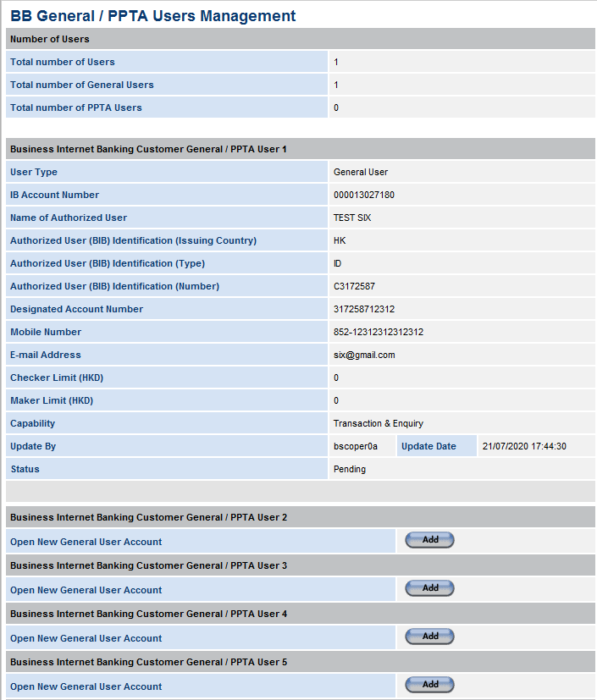

Screen 2.2.1.4‑a BIB User Management

Remarks:

1. A new section of showing number of users shall be added. Number of Primary User, General User & PPTA User.
2. IB Account Number, Checker Limit (HKD), Maker Limit (HKD) of General User or PPTA User shall be added.
3. A new option of User Type (General User / PPTA user) shall be added. A radio button is used to present the type of user. There is no default value on the type of user but it is a mandatory filed.
4. All General Users shall be displayed first and then PPTA User.

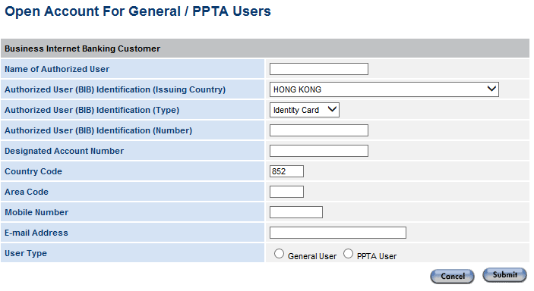

Screen 2.2.1.4‑b User Management Details

Remarks:

1. An option of “User Type” shall be added. Possible value is either General User or PPTA User.

Screen 2.2.1.4‑c Detail Customer Info (Include PPTA Users Information)

### BIB – First Time Registration of PPTA User (Account Activation)

#### Overview

This function is a new BIB function for PPTA User account activation

|  |  |
| --- | --- |
| **#** | **UFN** |
| 1 | FR-U-BIB-002 |

#### High-Level Implementation

Below is the high-level design and approach of the implementation.

1. Steps as shown below:

|  |  |  |
| --- | --- | --- |
|  | **Steps** | **Remarks** |
| 1 | Primary user must activate the BIB account before PPTA Users | PPTA Users cannot activate account before primary user |
| 2 | (PPTA Users) Perform the “First Time Registration” flow through BIB with the information below, to help the authentication of General Users.   * Business Registration Number (BR No.) * Identity No. of the PPTA Users | User authentication |
| 3 | Generate and input SMS OTP  ***Remarks: If the PPTA failed to perform verification for 4 consecutive times, the First Time Registration shall be freeze (i.e., make the function unavailable) for 24 hours to prevent brute force attempts*** | SMS OTP authentication |
| 4 | Set up the login ID and password, after the account authenticated. | Customized login ID & password |
| 5 | Accept T&C | Complete First Time Registration (account activation) |
| 6 | Welcome Page | To remind users to download soft token |

1. A new registration type “PPTA User” shall be added. In the page, user can select Primary User, General User or PPTA User for first time registration.
2. Freeze the First Time Registration if the SMS OTP authentication is failed 4 consecutive times. Apply this checking to General Users too.

#### Screen Flow Diagram

#### Screen (Reference)

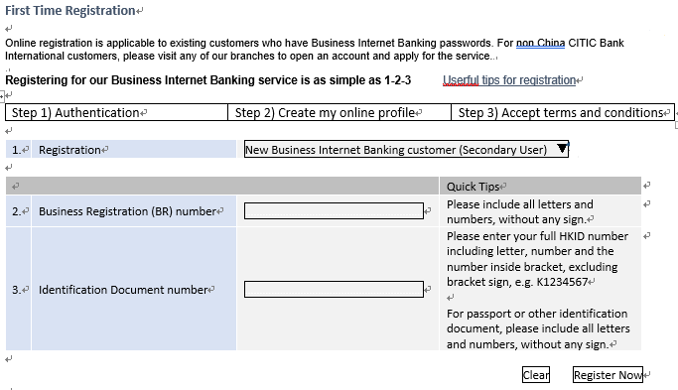

Screen 2.2.2.4‑a Step 1 Authentication

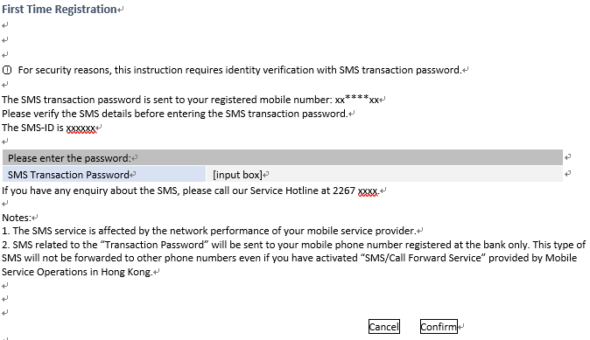

Screen 2.2.2.4‑b SMS OTP

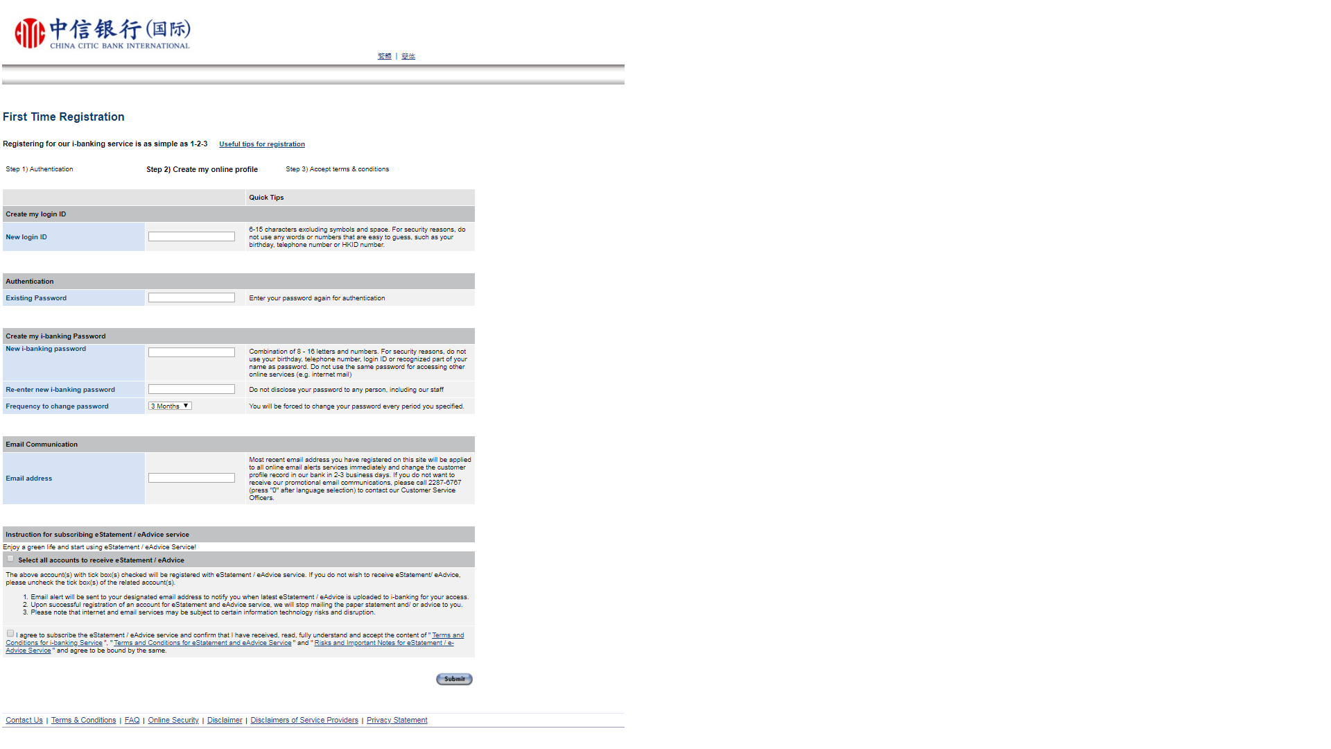

Screen 2.2.2.4‑c Step 2 Create my online profile

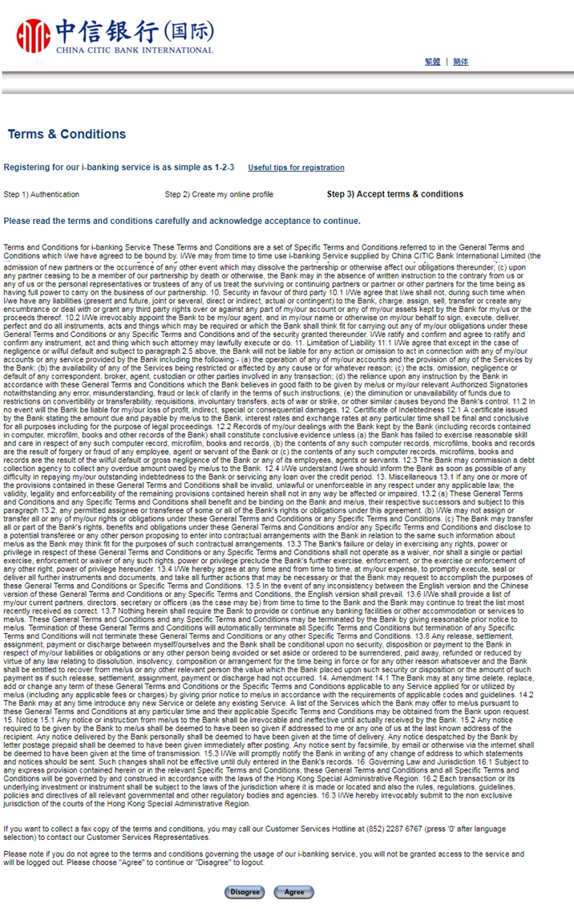

Screen 2.2.2.4‑d Step C Accept Terms & Conditions

### BIB – First Time Registration of General User (Account Activation)

#### Overview

The First Time Registration of General User shall be enhanced to add the checking on SMS OTP authentication. Freeze the function if the SMS OTP authentication is failed for 4 consecutive times as same as the PPTA Users.

|  |  |
| --- | --- |
| **#** | **UFN** |
| 1 | FR-U-BIB-006 |

#### High-Level Implementation

Below is the high-level design and the changes on this workflow:

1. Add the 4 consecutive times failure checking on SMS OTP authentication. The System shall freeze the First Time Registration for General User. The logic is identical to PPTA users. *(Remarks: This logic had been implemented by other vendor.)*
2. Remove the step of authentication by Hard Token. *(Remarks: This logic had been implemented by other vendor.)*
3. The System redirects to the welcome page which will show a reminder about asking user to download a soft token after accepting the terms and conditions. *(Remarks: This logic had been implemented by other vendor.)*

#### Screen Flow Diagram

### BIB – User Management Service

#### Overview

To enhance the function in order to cover the maintenance of the capability and approval limit for PPTA Users as well as to remove the PPTA Users.

|  |  |
| --- | --- |
| **#** | **UFN** |
| 1 | FR-G-BIB-003 |

#### High-Level Implementation

Below is the high-level design and approach of the implementation.

1. To extend the function to PPTA users.
2. To include the maintenance of the capability and approval Limit for PPTA Users.
3. To remove the PPTA User
   * If primary user removes all General User(s) and PPTA User(s), but there is still instruction(s) pending for approval, the System shall prompt an alert that there is pending instruction.
   * If primary user confirms to proceed, the pending for approval instruction(s) will be cancelled.
4. The PPTA User cannot logon to the BIB as same as General User once the Primary User is closed or suspend. Corresponding error message shall be prompted upon logon the BIB for this case.

#### Screen Flow Diagram

#### Screen (Reference)

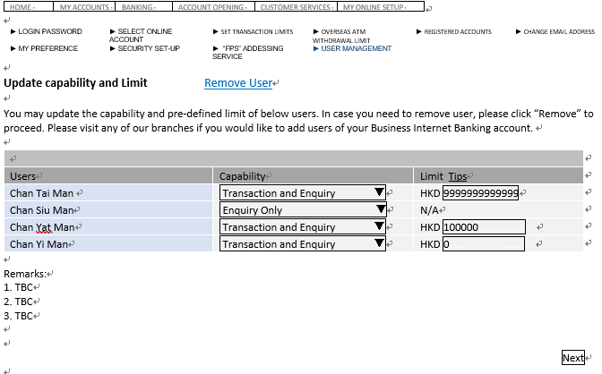

Screen 2.2.4.4‑a Update Capability and Limit

Remarks:

1. A new option “User Type” shall be added to identify the type of user either a General user or PPTS user.
2. All General User(s) shall be displayed first and then PPTA User(s)

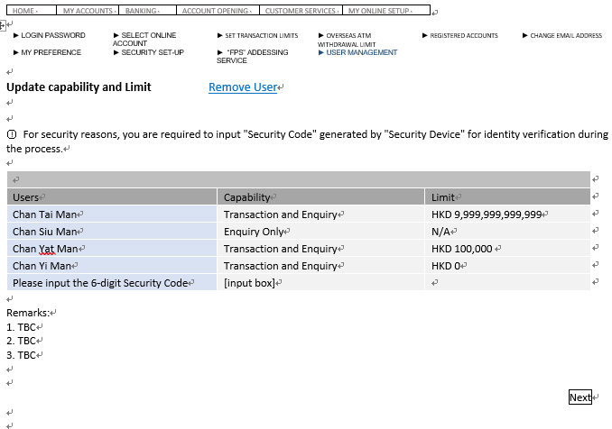

Screen 2.2.4.4‑b Identify Verification (Hard Token)

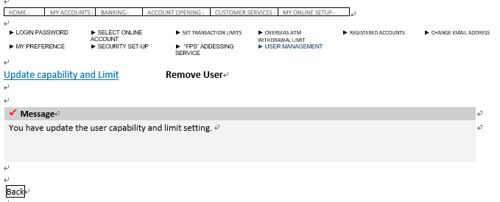

Screen 2.2.4.4‑c Result of Updating Capability and Limit

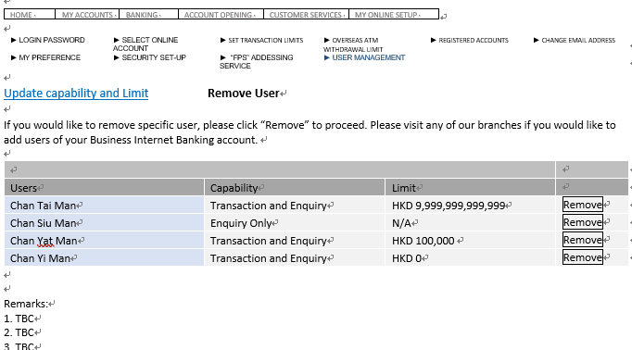

Screen 2.2.4.4‑d A new page of Remove User

Remarks:

1. A new option “User Type” shall be added to identify the type of user either a General user or PPTS user.
2. All General User(s) shall be displayed first and then PPTA User(s)

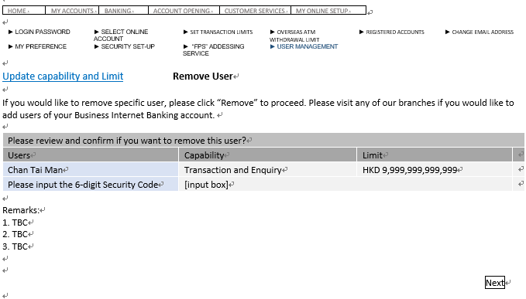

Screen 2.2.4.4‑e Identify Verification (Hard Token/Soft Token)

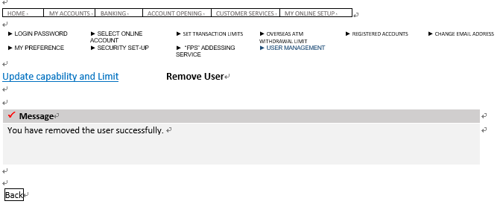

Screen 2.2.4.4‑f Result of Removing User

### BIB – Approval Request (Primary User & General User)

#### Overview

The existing BAU function of Approval Request shall be enhanced and relaxed to General User. Primary user and General User can make use of this function to review the submitted transaction by those General Users and/or PPTA Users. To approve or reject the transaction. In addition, a list of request transaction history last for 30 days is also provided.

|  |  |
| --- | --- |
| **#** | **UFN** |
| 1 | FR-G-BIB-001 |
| 2 | FR-G-BIB-003 |

#### High-Level Implementation

Below is the high-level design and approach of the implementation on that function.

1. To relax the function to Primary Users, General Users and PPTA Users.
2. The function shall be extended to those General Users and based on the approval limit to approve the request. The System would disallow the approval action if the checker limit is insufficient.
3. also PPTA user cannot approve/reject the request.
4. To enhance the function to cater the Payroll transaction submitted by General Users and/or PPTA Users.
5. To hide the function if number of General user and PPTA user of the BIB account is zero.
6. A new maker limit is introduced. The System would reject the required financial transaction(s) if the transaction amount (equivalent to HKD) were over than the maker limit of General User / PPTA User. Below are the confirmed financial transactions for reference.

|  |  |
| --- | --- |
| **Ref.** | **Function Name** |
| 1 | Fund Transfer |
| 2 | Bill Payment |
| 3 | Time Deposit |
| 4 | Remittance |
| 5 | Overseas ATM Withdrawal |
| 6 | Payroll Service |

#### Screen Flow Diagram

Remarks:

1. The workflow/function shall be extended for those General Users and PPTA Users.
2. Checker approval limit shall be added on the approval flow. The System shall reject the approval if checker’s limit is insufficient comparing with the transaction amount (equivalent to HKD).

#### Screen (Reference)

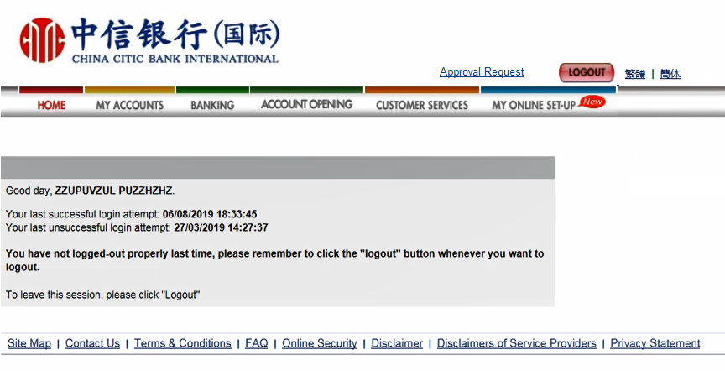

Screen 2.2.4.4‑a A new link of Approval Request to both Primary User and General User

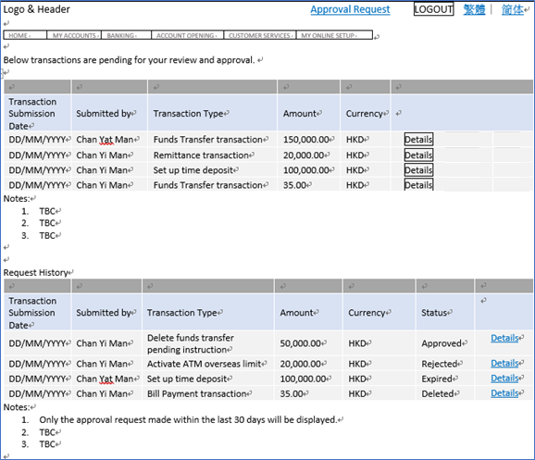

Screen 2.2.4.4‑b A new page of Approval Result

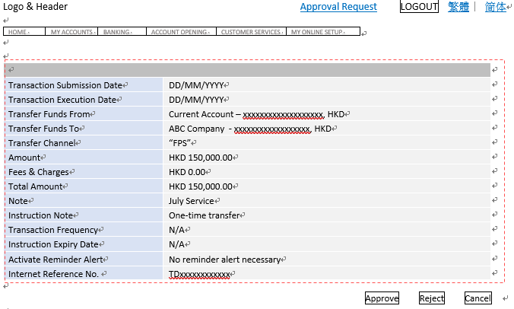

Screen 2.2.4.4‑c Detail Page of the Pending Instruction

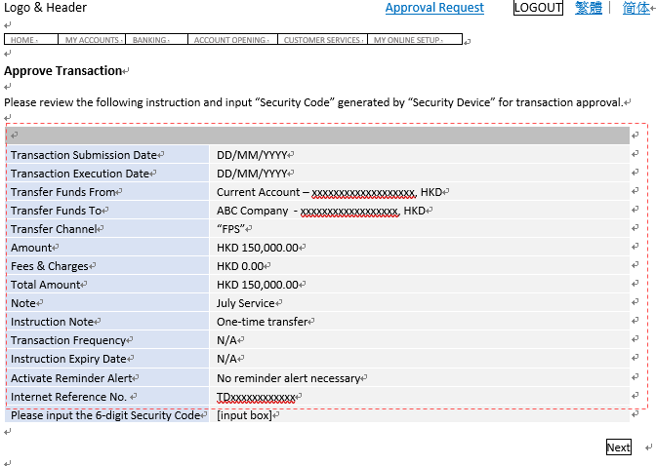

Screen 2.2.4.4‑d Identify Verification (Hard Token/Soft Token)

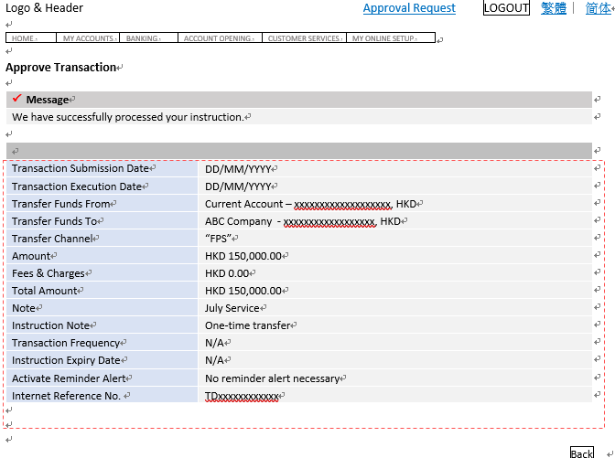

Screen 2.2.4.4‑e Result Page

### BIB – Support Trade X’press

#### Overview

Trade X’press function is added for those eligible BIB Customers.

|  |  |
| --- | --- |
| **#** | **UFN** |
| 1 | FR-G-BIB-005 |

#### High-Level Implementation

Below is the high-level design and approach of the implementation.

1. The Trade X’press function shall be added for BIB Customer. The System show the function if the requirement is met. All transactions making on Trade X’press function is not the scope of this function requirement specification.
2. There is a new daily batch job to capture the Trade X’press Information via processing an interface file provided by IMEX. Please refer to the Section 2.2.13 for details on the specification of interface file.
3. The Trade X’press function shall be enabled if the pre-requisites are met as follows:
   1. Customer has a Trade Account in CNCBI
   2. The Trade Account is
      1. BB Customer where RM Code equals to M88XX or B88XX
      2. Not Closed or Dormant where Account Status equals to “REGULAR”
      3. Affirmative Result on KYCC checking where the KYCC latest date > T – 365, where T stands for the system date of BIB
      4. Marked with Trade X’press eligible in IMEX where Trade Xpress is equal to “Y”
4. Perform allNETT Single Sign-On Solution when an eligible customer accesses the function.
   1. Generate a token “**GeneratedToken**” with this current BIB user
   2. Invoke the allNETT endpoint inside an iframe
      1. https://**allNETT_Server**:**allNETT_Port**/allNETTWeb/HttpGateWay?token=**GeneratedToken**&source=**bib**&entity=hk

|  |  |  |  |  |  |
| --- | --- | --- | --- | --- | --- |
| **Env.** | **allNETT_Server** | **allNETT_Port** | **token** | **source** | **entity** |
| UAT | 172.25.5.21 | 9444 | GeneratedToken | bib | hk |

* + 1. After received the request in i), allNETT invokes a new service call to be provided by BIB.

https://<PIBServer:Port>/CKWPortal/SSOLogin?token=**GeneratedToken**

* + 1. A new service call shall be implemented, and this new service call shall locate the user id based on the **GeneratedToken** from BIB table and return the following information as a response payload to allNETT system
       1. UserId
       2. StatusCode
       3. StatusDesc
    2. If the status is 200, allNETT system redirect the request to the landing page after the authentication.

#### Screen Flow Diagram

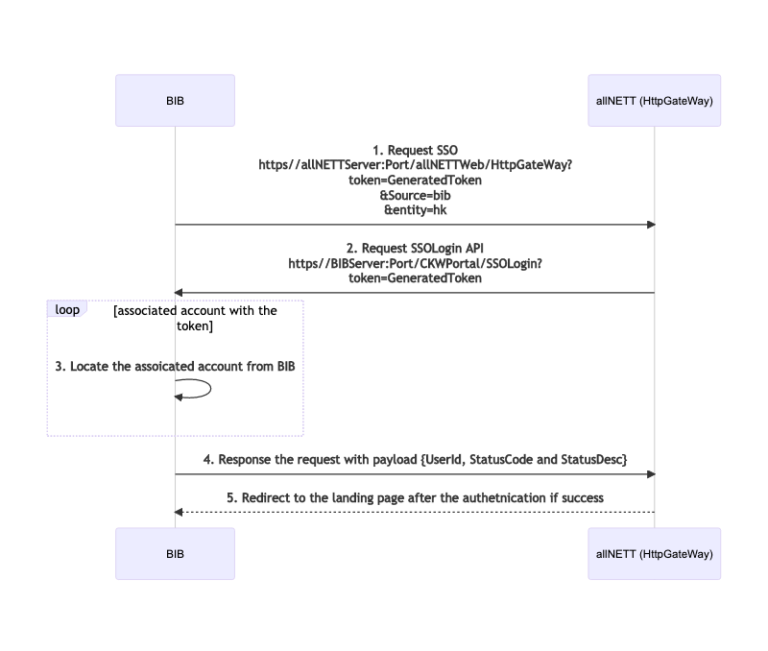

### BIB – Online Reset Password (PPTA User)

#### Overview

The online rest password function shall be enabled for PPTA User.

|  |  |
| --- | --- |
| **#** | **UFN** |
| 1 | FR-G-BIB-001 |

#### High-Level Implementation

Below is the high-level design and approach of the implementation.

1. To extend the function to PPTA User.
2. To enable the Soft Token on this function.
3. To re-use the UNE template for notifications upon successful online reset password.
4. To reset to default role and checker/maker limit once the password is reset successfully and apply this logic to General User too.

#### Screen Flow Diagram

#### Screen (Reference)

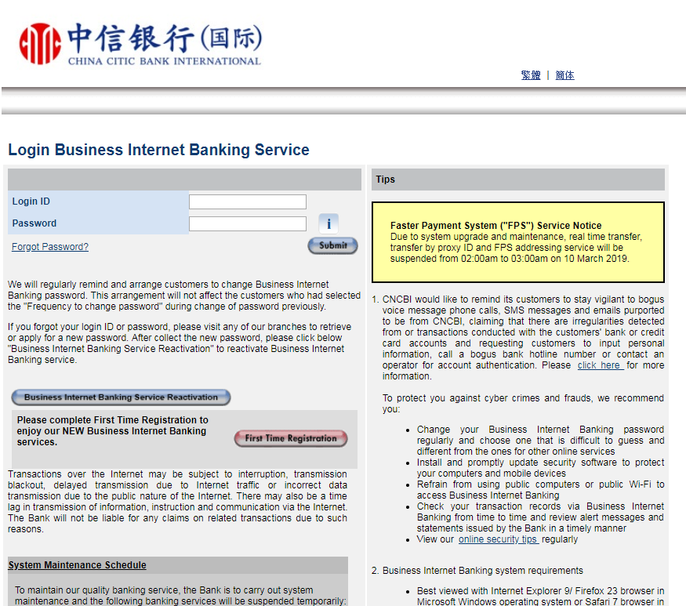

Screen 2.2.8.4‑a Enabled Forget Password

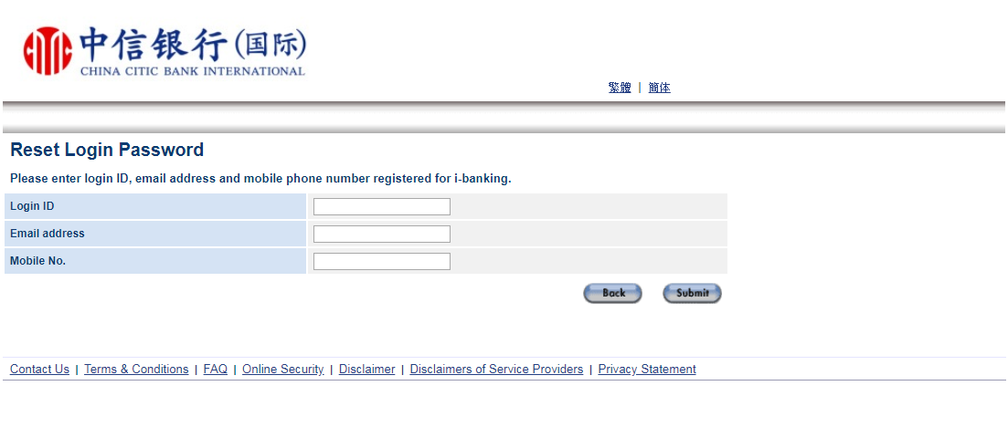

Screen 2.2.8.4‑b Online Reset Password Function

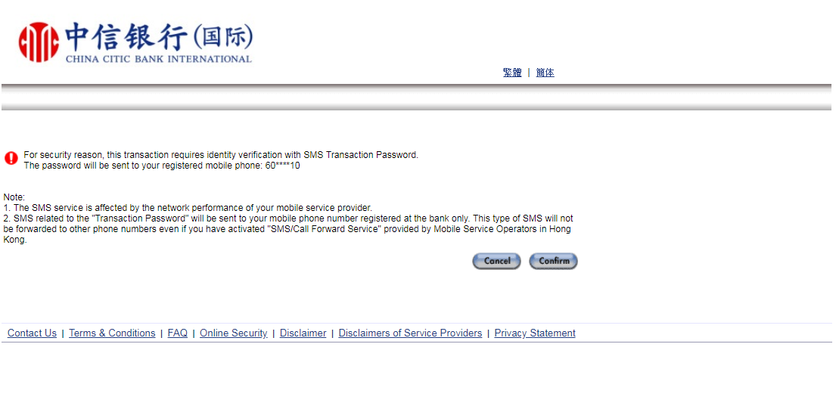

Screen 2.2.8.4‑c SMS Verification

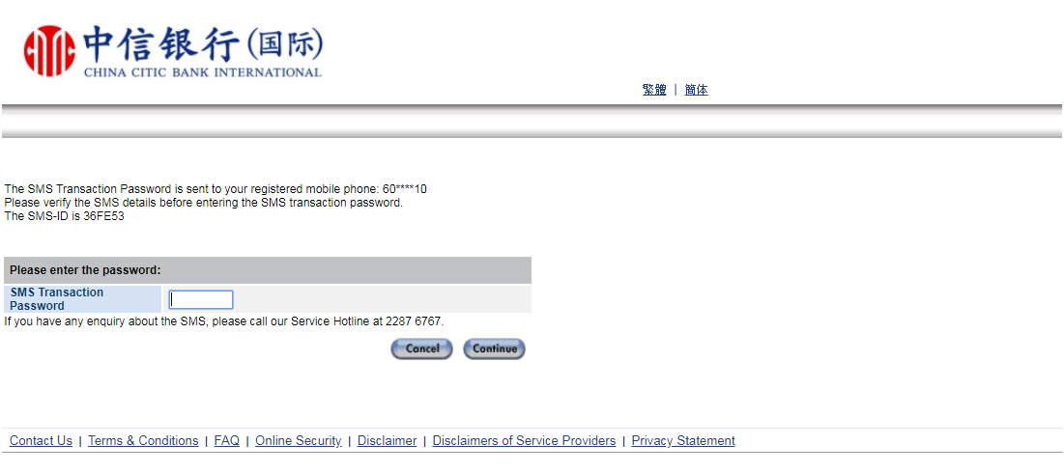

Screen 2.2.8.4‑d SMS OTP

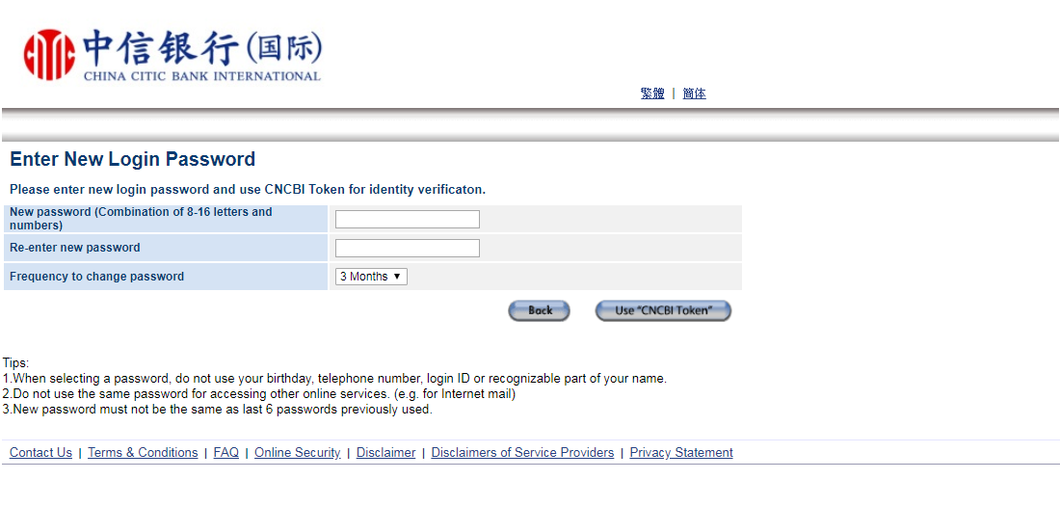

Screen 2.2.8.4‑e New Password

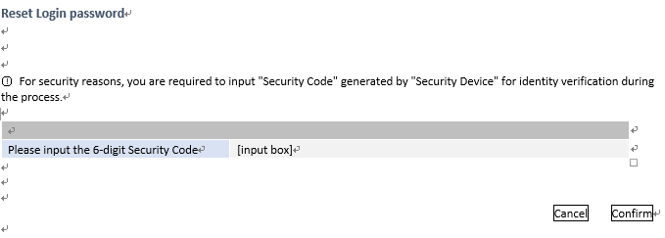

Screen 2.2.8.4‑f Identify Verification (Hard Token/Soft Token)

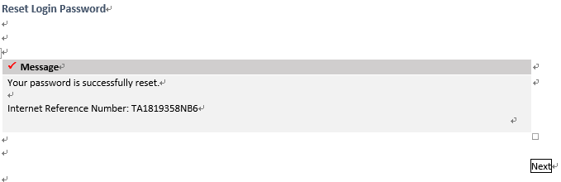

Screen 2.2.8.4‑g Result Page

### BIB - Support Remittance e-Advice

#### Overview

There are new batch jobs according to the URS.

|  |  |
| --- | --- |
| **#** | **UFN** |
| 1 | FR-G-BIB-009 |

#### High-Level Implementation

Below is the high-level design and approach of the implementation.

1. To support the Remittance and Load Payment for e-Advice
2. To include the Remittance and Load Payment options for viewing e-Advice and Maintenance
3. A bank-wide requirement and should also be applied to Personal Internet Banking (PIB)
4. For viewing e-Advice function, a new code for Remittance shall be added to TBL_PARAM as follows:

|  |  |  |  |  |
| --- | --- | --- | --- | --- |
| **PARAMCATCD** | **CD** | **ENGDESC** | **TCDESC** | **SCDESC** |
| AVQ_PRODUCT_CD | TBC | Remittance | 匯款 | 汇款 |

1. For Maintenance, a new code for Remittance shall be added to TBL_ESTMT_TYPE as follows:

|  |  |  |  |  |
| --- | --- | --- | --- | --- |
| **CD** | **DOC_TYPE** | **ENG_DSCP** | **TC_DSCP** | **SC_DSCP** |
| TBC | M | Remittance | 匯款 | 汇款 |
| TBC | N/A or blank | Remittance | 匯款 | 汇款 |

1. Apply the above changes to BO application

#### Screen Flow Diagram

AS-IS.

#### Screen (Reference)

Screen 2.2.9.4‑a View e-Advice

Remarks:

1. Remittance and Loan Payment shall be added on the Product Type for selection

Screen 2.2.9.4‑b Maintenance

Remarks:

1. Remittance and Loan Payment shall be added for selection

### BIB – Relaxation of Soft Token Restrictions

#### Overview

Relaxation of Soft Token restrictions for BIB Customers. Below restrictions shall be removed from BIB Customers

1. The usage of the created templates will not be available until 24-hour after 2FA
2. Halved Transaction Limit

|  |  |
| --- | --- |
| **#** | **UFN** |
| 1 | FR-G-BIB-004 |
| 2 | FR-S-BIB-004 |

#### High-Level Implementation

Below is the high-level design and approach of the implementation.

1. Below is the function for those creation of templates, based on the existing soft token restrictions, to remove the logic if the current user is a BIB customer
   1. Bill Payment Template Creation
   2. Fund Transfer Template Creation
   3. Remittance Template Creation
2. Remove the Halved Transaction Limit for Soft Token if the current user is a BIB Customer
   1. The halved transaction limit is defined in system parameter with code “SOFT_TKN_LIMIT_PER”
   2. The System should ignore the calculation with this defined value for BIB Customer

#### Screen Flow Diagram

AS-IS.

### BO – Enquiry on BIB Trade X’press Information

#### Overview

To enquire the BIB customer if eligible for Trade X’press via BO application.

|  |  |
| --- | --- |
| **#** | **UFN** |
| 1 | FR-G-BIB-005 |

#### High-Level Implementation

Below is the high-level design and approach of the implementation.

1. A new enquiry function “Trade X’press” shall be added on BO application with the Navigation: CUSTOMER ENQUIRY > IB ACCT MAINTENANCE > Trade X’press
2. To obtain the detailed information from the newly created table TBL_BB_TRADE_XPRESS
   1. Last System Update Time
   2. RMID
   3. Account Status from IMEX
   4. KYCC Latest Date from IMEX
   5. Trade Xpress from IMEX

#### Screen Flow Diagram

TBC

#### Screen (Reference)

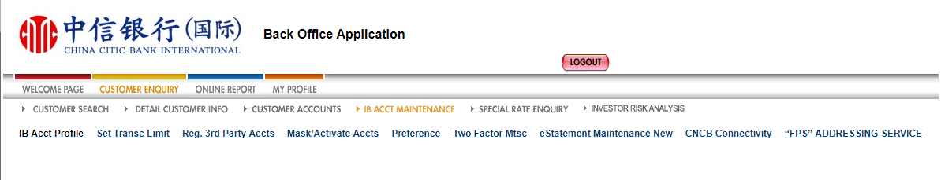

Trade X’press

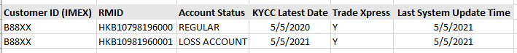

### BO – Client Group with Higher Transaction Limits

#### Overview

To define a new set of transaction limit for the special PBG clients.

|  |  |
| --- | --- |
| **#** | **UFN** |
| 1 | FR-G-BIB-012 |

#### High-Level Implementation

Below is the high-level design and approach of the implementation.

1. The function of “Set Transc Limit" shall be enhanced to allow the amendment on the maximum Limit of transaction type for BIB Customer.
2. To enable this feature for BIB Customer only. No changes on PIB Customer.

#### Screen Flow Diagram

AS-IS.

### IbBatchJob – BIB Users Name Scanning

#### Overview

A new batch job to generate an interface file for AML name screening. Only the customer name of PPTA User shall be captured in this interface file.

|  |  |
| --- | --- |
| **#** | **UFN** |
| 1 | FR-A-BIB-002 |
| 2 | FR-A-BIB-008 |

Below is a new batch job to be implemented in IbBatchJobs.

|  |  |  |
| --- | --- | --- |
| **Jobs** | **Description** | **Execution Time** |
| BIBUsersNameScanning | A new batch job to general a FIRCO required format for AML name screening | Daily |

#### High-Level Implementation

Below is the high-level design and approach of the implementation.

1. A new IbBatchJob and get the name of PPTA user which was created one day before the job’s execution date.
2. Collect the FIRCO required information according to the FIRCO’s interface file specification and generate an interface file with fixed-length format.
3. Capture the customer name of PPTA user only.
4. Below is the required specification of interface file the System shall be followed to generate the file for name scanning.





### IbBatchJob – BO Enquiry on BIB Trade X’press Information

#### Overview

A new batch to capture the Trade X’press information which shall be provided by IMEX.

|  |  |
| --- | --- |
| **#** | **UFN** |
| 1 | FR-A-BIB-005 |

Below is a new batch job to be implemented in IbBatchJobs.

|  |  |  |
| --- | --- | --- |
| **Jobs** | **Description** | **Execution Time** |
| BIBTradeXpress | A new batch job to capture the  Trade X’press information of BIB customer. | Daily |

#### High-Level Implementation

Below is the high-level design and approach of the implementation.

1. A new batch job to be implemented to capture the Trade X’press information provided by IMEX via an interface file.
2. The Trade X’press Information shall include the

|  |  |
| --- | --- |
| **Field Name** | **Description** |
|
| CUSTOMER_ID | Customer ID of IMEX |
| ACCOUNT_STATUS | Account status |
| KYCC_DATE | KYCC Date |
| TRADE_XPRESS_STATUS | Trade express status |
| CIF_ID | CIF ID / RMID |

1. The Trade X’press Information shall be stored on a new table TBL_BB_TRADE_XPRESS
2. Below is the specification of interface file



### BO - MIS Reports

#### Overview

Below are the MIS reports to be enhanced or created.

|  |  |  |
| --- | --- | --- |
| **MIS Reports** | **Description** | **Type** |
| IBAuditTrailReport(BB).csv | Audit Trail Report | Daily |
|  |  |  |

**Remarks**

1. To be enhanced to include the event of creation/suspension/deletion of PPTA users.

### BO - System Parameter Setting

#### Overview

Below is the table listing those system parameters to be added/updated.

|  |  |  |  |
| --- | --- | --- | --- |
| **Parameter Name** | **Description** | **New/Existing** | **Initial Value** |
| BB_NUM_SEC_USERS | Maximum number of General Users/PPTA to be created for a company | Existing | 20 |

# Technical Design

## System Architecture Diagram

The System Architecture Design remains the same as existing Business Internet Banking applications since there is no new hardware or new set of physical components is introduced for the implementation of new multiple user management for Business Internet Banking customers.

## Implementation Overview

In general, the Business Internet Banking shall be enhanced to having a multiple user package with maker checker mechanism. 1 Primary User and maximum 20 General Users + PPTA Users.

The pre-defined approval limit shall be replaced by the Maker Limit and Checker Limit. The existing maker-checker mechanism shall be modified to incorporate with the Maker Limit and Checker Limit instead of the pre-defined approval limit.

Below is the implementation summary:

* BO – Modify the value of system parameter “BB_NUM_SEC_USERS” from 4 to 20.
* BO – BIB User Management shall be enhanced to support
  + 1. PPTA User – Creation/Suspension/Deletion
    2. To show the figures of number user (Primary User, General User and PPTA User)
    3. To show IB Account No of General User and PPTA User
* BO – Customer Search shall be enhanced to filter
  + 1. PPTA User
* BO – Customer Detail Page shall be enhanced to show
  + 1. PPTA User’s information
* BIB – First Time Registration shall be enhanced to support
  + 1. PPTA User
    2. The page should have a new registration type for PPTA User
* BIB – Payroll Service shall be proceeded under maker-checker workflow
* BIB – Submission of Financial Transactions shall be checked with Maker Limit
* BIB – Approval of Financial Transactions which is requested/submitted by General User/PPTA User shall be checked with Checker Limit
* BIB – Remittance e-Advice shall be supported
* BIB – Online Reset Password shall be enhanced to support
  + 1. PPTA User
    2. Reset the role and limit to its default value once the password is reset successfully
    3. Soft-token should be supported
* The existing table “TBL_BB_USER” shall be enhanced to support the maker limit and checker limit.
* A new batch job shall be implemented for the name scanning of PPTA user
* A new web service call to be implemented for the allNETT SSO handshaking.

## Sequence Diagram

N/A

## Database Schema

|  |  |  |  |  |  |
| --- | --- | --- | --- | --- | --- |
| **Entity Name:** | **TBL_BB_USER** | | | | |
| **Schema** | **Enhance** |  |  |  |  |
| **Data Item** | **Description** | **Format** | **Nullable** | **Default** | **Key** |
| MAKER_LIMIT | Maker Limit | NUMBER(15,2) | Yes | 0 |  |
| USER_TYPE | User Type | VARCHAR2(5) | Yes |  |  |

|  |  |  |  |  |  |
| --- | --- | --- | --- | --- | --- |
| **Entity Name:** | **TBL_BB_TRADE_XPRESS** | | | | |
| **Schema** | **New** |  |  |  |  |
| **Data Item** | **Description** | **Format** | **Nullable** | **Default** | **Key** |
| ID | Record ID | VARCHAR2(32) | No | sys_guid() | Primary |
| CUSTOMER_ID | Customer ID from IMEX | VARCHAR2(15) | No |  |  |
| RMID | RMID of Customer | VARCHAR2(50) | No |  |  |
| STATUS | Account Status from IMEX | VARCHAR2(50) | No |  |  |
| KYCC_DATE | KYCC Latest Date from IMEX | DATE | No |  |  |
| TRADE_XPRESS | Trade Xpress in IMEX | VARCHAR2(1) | No |  |  |
| CREATED_BY | Record created by | VARCHAR2(50) | Yes |  |  |
| DT_CREATED | Record created datetime | DATE | Yes |  |  |
| UPDATED_BY | Record updated by | VARCHAR2(50) | Yes |  |  |
| DT_UPDATED | Record updated datetime | DATE | Yes |  |  |

## System Code for Function Menu

Configuration

* TBL_SYS_CONST

|  |  |  |  |
| --- | --- | --- | --- |
| CD | PARAM_CAT_CD | ENG_DESC | ACT_CHANNEL |
| TBC |  |  |  |
|  |  |  |  |
|  |  |  |  |
|  |  |  |  |

* TBL_IB_FUNCTION

|  |  |
| --- | --- |
| SYS_CONST_MODULE_CD | SYS_CONST_FUNCTION_CD |
|  |  |

* TBL_IB_SUB_FUNCTION

|  |  |
| --- | --- |
| SYS_CONST_SUB_FUNCTION_CD | TBC |
| IS_TYPHOON_ALLOWD | 1 |
| IS_HOLDIAY_FUNCTION | 1 |
| IS_HOL_ALLOWED | 1 |
| IS_SPECIAL_DAY_ALLOWED | 1 |
| IS_FINANCIAL_FUNCTION | 0 |
| IS_FUNCTION_SETTING | 1 |
| IS_WRK_HR_FUNCTION | 1 |
| FUNCTION_TYPE_CD | T |
| IS_ENABLED | 1 |
| IS_FIN_DISPLAY | 0 |
| IS_HIGH_RISK_TX | 1 |
| IS_NIO_ALLOWED | 0 |
| IS_PB_ALLOWED | 1 |

## Program Modules – Business Internet Banking (BIB)

### Configuration

NIL

# Appendix

## Validation/Error Message

|  |  |
| --- | --- |
| Key | EN_US |
| Common Error Message: | |
| COM100002 | Please input {0}. |
| COM100010 | {0} should be numeric. Please re-enter. |
| COM100014 | {0} should be less than {1}. Please re-enter. |
| COM100038 | Sorry, we are unable to process your instruction right now. Please call 2287 6767 (Press "0" after language selection) to contact our Product Specialist for assistance. |
| COM100080 | Invalid account number {0}. Please re-enter. |
| COM100085 | {0} should be less than or equal to {1}. Please re-enter. |
| COM100087 | Please select {0}. |
| Error Message for BIB: | |
| BIB00001 |  |
| BIB00002 |  |
| BIB00003 |  |
| BIB00004 |  |
| BIB00005 |  |
| BIB00006 |  |
| BIB00009 |  |
| BIB00010 |  |
| BIB00099 |  |

where {0} and {1} is parameter value.

## 

## Audit Log Template

### Add/Delete/Suspend General User/PPTA User

<message>

<data>

<is_properties value="N"/>

</data>

<recordsets>

<record-bib_open_acc >

<header>

                <ib_acct_no/>

                <auth_nm>

                <auth_country_code/>

                <auth_id_type/>

                <auth_id_no/>

                <designated_acct_no/>

                <capability/>

                <limit/>

                <user_type/>

</header>

<row>

<ib_acct_no value="IB Acct No."/>

                <auth_nm value="Authorized Name"/>

                <auth_country_code value="Authorized Country Code"/>

                <auth_id_type value="Authorized ID Type" />

                <auth_id_no value="Authorized ID No"/>

                <designated_acct_no value="Designated Acct No"/>

                <capability value="Capability"/>

                <limit value="Approval Limit (HKD)"/>

                <user_type value="General User/PPTA User"/>

</row>

</record-bib_open_acc>

</recordsets>

</message>

Template 4.2.1-a Audit Log Template of Add/Delete/Suspend General User

Configuration

* TBL_AUDIT_IMG_TMP

|  |  |  |  |
| --- | --- | --- | --- |
| **CHANNEL_CD** | **FUNCTION_TYPE** | **ACTION_TYPE** | **TEMPLATE** |
| PIB |  | Delete | Template 4.2.1-a |
| BO |  | Insert/Update/Delete | Template 4.2.1-a |